 

**ACCIDENT SENSING AND PREVENTION USING IOT**

**A PROJECT REPORT**

***Submitted by***

**ABIRAME M R S**

**MADHUPRIYA A**

**NIKALYA R**

**PRITHIUSHA M**

***In partial fulfillment for the award of the degree***

***Of***

## BACHOLER OF TECHNOLOGY

***in***

**INFORMATION TECHNOLOGY**

**KONGUNADU COLLEGE OF ENGINEERING AND TECHNOLOGY**

**(AUTONOMOUS)**

## ANNA UNIVERSITY :: CHENNAI 600 025

**APRIL 2023**

**KONGUNADU COLLEGE OF ENGINEERING AND TECHNOLOGY**

**(AUTONOMOUS)**

## ANNA UNIVERSITY :: CHENNAI 600 025

**BONAFIDE CERTIFICATE**

Certified that this project report “**ACCIDENT SENSING AND PREVENTION USING IOT**” is the bonafide work of **“ABIRAME M R S (621319205002), MADHUPRIYA A (621319205018), NIKALYA R (621319205027), PRITHIUSHA M (621318205047)”** who carried out the project work under my supervision.

|  |  |
| --- | --- |
| **SIGNATURE** | **SIGNATURE** |
| **HEAD OF THE DEPARTMENT** | **SUPERVISOR** |
| MR. N. PREMKUMAR, M.E., (Ph. D) | DR. R. SATHYA, Ph. D |
| Associate Professor, | Assistant Professor, |
| Department of Information Technology, | Department of Information Technology, |
| Kongunadu College of Engineering and Technology, Thottiam, Trichy-621 215 | Kongunadu College of Engineering and Technology, Thottiam, Trichy-621 215 |

Submitted for the project viva-voce examination held on

**INTERNAL EXAMINER EXTERNAL EXAMINER**

ABSTRACT

Traveling has become risky despite being a vital necessity for human existence. The frequency of traffic accidents is rising over time. According to a recent Times India study, there have been 2 lakhs of documented occurrences of fatal road accidents. Additionally, the recorded mortality instances, almost two-thirds were the result of drunk driving and delayed medical recovery. In this proposed project, Node MCU is used to transmit messages when the vehicle is met with an accident normally. Additionally, the system is going to detect whether the person who is driving car is drunk or not and we are going to control the vehicle. This can be done using Arduino IOT Devices. When the driver is boozed, the alcoholic sensor will detect it, if the alcohol is detected then immediately it will be notified, and also the speed of the engine will be reduced. In case the vehicle met with an accident after the alcohol is sensed, immediately the vehicle engine will be getting stopped and to be get notified.

## ACKNOWLEDGEMENT

We wish to express our sincere gratitude to our beloved chairman **Dr.PSK.R.PERIASWAMY** for providing the facilitation to make us extensively inter- nationalized to meet global competence with almost perfection.

We would like to express our sincere thanks to our Principal **Dr.R.ASHOKAN, M.S., M.Tech., Ph.D.,** for the facilities and the encouragement given to the progression and completion of this project.

We proudly render our immense gratitude to **Mr.N.PREMKUMAR, M.E., (Ph.D.),** Associate Professor and Head of the Department, Department of Information Technology for his effective leadership, encouragement and supportive guidance to this project.

We proudly render our thanks to our Project Coordinator **Dr.K.MUTHUMANICKAM, M.E., Ph.D.,** Professor, Department of Information Technology for his valuable ideas, encouragement and supportive guidance throughout this project.

We wish to extend our heartfelt regard and sincere thanks to our project guide **Dr.R.SATHYA, M.E., Ph.D.,** Assistant Professor, Department of Information Technology for her Motivation, Continuous encouragement and expert guidance throughout this project.

We wish to extend our sincere thanks to all faculty members of Information Technology department for their valuable suggestions, kind cooperation and encouragement on successful completion of this project.

Finally, we profound gratitude to the almighty for his presence and who gave me the bravery, privilege, power and belief to complete this project.

|  |  |  |
| --- | --- | --- |
|  | **TABLE OF CONTENT** |  |
| **CHAPTER NO** | **TITLE** | **PAGE NO** |
|  | **ABSTRACT** | **iii** |
|  | **LIST OF TABLES** | **viii** |
|  | **LIST OF FIGURES** | **ix** |
|  | **LIST OF ABBREVATIONS** | **x** |
| **1** | **INTRODUCTION** | **1** |
|  | 1.1 INTRA-VEHICLE CONNECTIVITY | 3 |
| **2** | **LITERATURE SURVEY** | **5** |
| **3** | **SYSTEM ANALYSIS** | **15** |
|  | 3.1 EXISTING SYSTEM | 15 |
|  | 3.2 DISADVANTAGES OF EXISTING  SYSTEM | 15 |
|  | 3.3 PROPOSED SYSTEM | 16 |
|  | 3.4 ADVANTAGES OF PROPOSED SYSTEM | 16 |
| **4** | **SYSTEM DESIGN** | **17** |
|  | 4.1 HARDWARE IMPLEMENTATION | 17 |
|  | 4.2 ARDUINO UNO | 18 |
|  | 4.3 GENERAL PIN FUNCTIONS | 19 |
|  | 4.4 SPECIAL PIN FUNCTIONS | 19 |
|  | 4.5 LCD DISPLAY | 20 |
|  | 4.6 POWER SUPPLY | 22 |
|  | 4.7 STEPS INVOLOVED IN POWER SUPPLY | 22 |
|  | 4.8 FILTER | 23 |
|  | 4.9 MQ3 – ALCOHOL GAS SENSOR | 23 |
|  | 4.10 MOTOR DRIVE | 24 |
|  | 4.11 GEARED DC MOTOR | 24 |
| **5** | **SYSTEM REQUIREMENTS** | **25** |
|  | 5.1 HARDWARE REQUIREMENTS | 25 |
|  | 5.2 SOFTWARE REQUIREMENTS | 25 |
| **6** | **IMPLEMENTATION OF PROPOSED ACCIDENT ANALYSING SYSTEM** | **26** |
|  | 6.1 WORK FLOW FOR ACCIDENT  ANALYSING SYSTEM | 26 |
|  | 6.2 MODULES | 27 |
|  | 6.3 ACCIDENT SENSING | 27 |
|  | 6.4 DRUNK AND DRIVE DETECTION AND  SPEED CONTROL | 28 |
|  | 6.5 USER MODULES | 28 |
|  | 6.6 DRIVER LEVEL MANAGEMENT | 29 |
|  | 6.7 MONITORING SYSTEM | 29 |
|  | 6.8 PERFORMANCE EVALUATIONS | 29 |
| **7** | **HARDWARE & SOFTWARE REQUIREMENTS** | **30** |
|  | 7.1 ARDUINO IDE | 30 |
|  | 7.2 EMBEDDED C | 30 |
| **8** | **TESTING** | **31** |
|  | 8.1 SYSTEM TESTING | 31 |
|  | 8.2 UNIT TESTING | 31 |
|  | 8.3 INTEGRATION TESTING | 31 |
| **9** | **EXPERIMENTAL RESULTS AND DISCUSSION** | **32** |
|  | 9.1 RESULTS OF VEHICLE ACCIDENT  SENSING | 32 |
|  | 9.2 RESULTS OF VEHICLE ALCOHOL  DETECTION | 33 |
|  | 9.3 RESULTS OF SPEED ALERT  DETECTION | 33 |
|  | 9.4 RESULTS OF ACCIDENT RECOGNITION  USING CNN | 34 |
|  | 9.5 DISCUSSION | 34 |
| **10** | **CONCLUSION & FUTURE WORK** | **36** |
| **11** | **APPENDICES** | **37** |
|  | 11.1 SAMPLE CODE | 37 |
|  | 11.2 SCREENSHOTS | 47 |
|  | **REFERENCE** | **50** |
|  | **LIST OF PUBLICATIONS** | **52** |

|  |  |  |
| --- | --- | --- |
| **LIST OF TABLES** | | |
| **TABLE NO** | **TABLE NAME** | **PAGE NO** |
| 4.1 | SPECIFICATION OF LCD DISPLAY | 21 |

|  |  |  |
| --- | --- | --- |
| **LIST OF FIGURES** | | |
| **FIGURE NO** | **NAME OF FIGURES** | **PAGE NO** |
| 4.1 | EXPERIMENTAL SETUP OF ACCIDENT SENSING ANDACCIDENT DETECTION PHASE | 17 |
| 4.2 | ARDUINO UNO | 18 |
| 4.3 | LCD DISPLAY | 21 |
| 4.4 | MQ – 3 ALCOHOL SENSOR | 24 |
| 6.1 | WORKFLOW OFACCIDENT ANALYSING SYSTEM | 26 |
| 6.2 | ACCIDENT SENSING | 27 |
| 6.3 | DRUNK AND DRIVE DETECTION AND SPEED CONTRL | 28 |
| 9.1 | FLOW OF ACCIDENT SENSING | 32 |
| 9.2 | ALCOHOL DETECTED FLOW | 33 |
| 9.3 | SPEED ALERT | 34 |
| 11.1 | IGNITION OFF STATE | 47 |
| 11.2 | IGNITION ON STATE | 47 |
| 11.3 | ACCIDENT DETECTED STATE | 48 |
| 11.4 | ALCOHOL DETECTED STATE | 48 |
| 11.5 | ALCOHOL AND ACCIDENT DETECTED STATE | 49 |

|  |  |
| --- | --- |
| **LIST OF ABBREVATIONS** | |
| **ECU** | Engine Control Unit |
| **ITS** | Intelligent transportation systems |
| **AP** | Accident-prone |
| **FPR** | False Positive Rate |
| **MLP** | Multilayer Preceptor |
| **DNN** | Deep Neural Networks |
| **DBN** | Deep Belief Network |
| **CNN** | Convolutional Neural Network |
| **IoT** | Internet of Things |
| **ADC** | Accident Detection and Classification |
| **EMS** | Emergency Medical Services |
| **NB** | Naive Bayes |
| **GMM** | Gaussian Mixture Model |
| **DT** | Decision Tree |
| **ALA** | Absolute Linear Acceleration |
| **LCD** | Liquid Crystal Display |
| **IDE**  **CAM** | Integrated Development Environment  Class Activation Map |

# CHAPTER 1 INTRODUCTION

Public health is now very concerned about the problem of road safety. In 2019, there were more than 1,37,000 road fatalities. Driving while intoxicated has been a major contributing factor in many recent traffic accidents. The main goal of the proposed system, dubbed “Drunk and Drive Detection using IoT”, is to locate drunk drivers and avoid collisions by disabling their cars. The car has this system fitted. When a driver is intoxicated and operating a vehicle, an alcohol sensor installed inside the vehicle can identify alcohol on the driver's breath. Both the front and rear of the car have Ultraviolet monitors. If another car or another object is close by, the speed of the car will reduce. When an accident happens, the vibration sensor alerts the relative's mobile phone-based drunken driving detection. “Alcohol Detection with Vehicle Controlling” instantly cautions the driver or alerts the police or family if there is any indication of drunk driving.

This method is primarily used to stop accidents caused by inebriated driving. The printed circuit board is linked to a sensor for alcohol. When the driver's blood alcohol content is above the legal limit, the car should have a mechanism that turns off the ignition. An Android phone with a few sensors and a programmer installed is required for this setup. The current sensor readings are compared to the system's existing figures by this programmer. If a match is discovered, a message with the address and a warning will be sent. According to this strategy, inebriated driving is the main contributing factor to accidents. They created a system based on actual driving test scenarios to determine the driver's condition. The car has sensors and a mobile device fitted as custom hardware.

The sensor measurements from the car are compared to the outcomes of the real-time test case while the driver is in charge. The sensors in this system are pointed straight at the faces of the drivers. The Internet of Things is a network of numerous uniquely identifiable things that can communicate with one another online. In the IoT, a single gadget can be applied in a variety of ways. It also examines various models that have already been put forth and makes an effort to take the best aspects of them into account. In order to detect intoxication and take preventative action, it analyses the alcohol level and the speed at which the car is turned.

A warning will sound, the speed limit will be lowered, traffic control will be informed, and automatic operation will start. Wirelessly connected cars are expected to be the next development in the automobile revolution given the rapid advancement of information and communication technology. Vehicle networking will open up new avenues for safe travel, intelligent transportation, and eco-friendly transportation. The demand for mobile internet connectivity among users, environmental preservation, and road safety are the driving forces behind wireless solutions for vehicular networking. Accidental fatalities happen more often now than they used to. A total of 3, 94, 982 accidental deaths occurred in India in 2021, a 1.0% rise from the year before.

This equates to 4,098 more accidental fatalities in 2021 than in 2020. Urbanization is growing, so there is a rise. Large cities' high vehicle populations are to blame for traffic congestion and all of its negative side effects, including significant monetary expenses and environmental issues. Vehicle networking is a term used to characterize wireless connections between an automobile's interior and exterior communications. Before providing a solution in each of the two parts, vehicle-to-road connectivity is described and inter-vehicle connectivity options are covered.

**1.1 INTRA-VEHICLE CONNECTIVITY**

The Car communication Consortium was established by Daimler, General Motors, Honda, Hyundai, Toyota, and Volkswagen along with Nokia, Samsung, and other companies with the goal of developing common standards for mobile device and vehicle communication. Intra-vehicle wired connections require numerous cable connections between sensors and the Electrical Control Unit (ECU), where the sensors transmit event-driven or time-driven messages. A fascinating option where the ECU and sensor are connected by the same network is now feasible thanks to recent advancements in wireless sensor networking and communication.

To build intra-vehicle wireless sensor networks, a variety of wireless technologies are accessible, and research has concentrated on the viability of different wireless options in such environment’s challenges are:

1. The intra-vehicle communication situation is difficult due to the severe scattering of sensors in a very compact area and the frequent loss of line of sight.
2. **Bluetooth:** The IEEE 802.1 Standard is used by Bluetooth, a 2.4GHz ISM frequency band wireless device, to share data over short distances. A main Bluetooth device can communicate with a maximum of seven devices. It permits data transfers between portable devices at speeds of up to 3 Mbps.
3. **ZigBee:** A standard for personal area networks composed of mobile, low-power digital radios are the ZigBee family of high-level communication standards. It usually operates at 2.4 GHz in most nations, while also operating at 868 MHz in Europe, and 915 MHz in the USA and Australia. Data speeds vary from 20 kbps to 250 kbps.
4. **Ultra-wide band:** A large portion of the radio spectrum is utilized by UWB, a radio technology, for short-range, high-bandwidth communications at very low energy levels. The operating range of UWB, which has a 7.5GHz frequency, is 3.1 to 10.6 GHz. UWB can enable short-range conversations at data rates of up to 480Mbps. Low cost, high time domain resolution for tracking and localization apps, and resistance to wireless fading and shadowing are all benefits of UWB systems.
5. **60 GHz Millimeter Wave:** Communications at the 60 GHz range, also known as millimeter-wave communications, which operate in the 57-64 GHz frequency range, offer an alternative method for building intra-vehicular connectivity. They can handle multiple-Gaps wireless connections over short distances for bandwidth-hungry multimedia applications. Growing research interest has been generated by the application of mm-Wave communication technology to multimedia transmission in the intra-vehicle environment, such as high-definition video transmission for seat monitors in the car.
6. **Near field communication:** Smart phones and other devices can interact wirelessly with one another using the NFC set of protocols by touching or bringing them close to one another, usually within 10 cm (3.9 in) or less. Both NFC and Bluetooth are short-range communication technologies. NFC sets up more quickly than Bluetooth low energy, but it transmits data at a slower pace. The highest data transfer rate for NFC is lowers (424 kbps).

# 

# CHAPTER 2

# LITERATURE SURVEY

**TITLE 1:** Intelligent Traffic Accident Prediction Model for Internet of Vehicles with Deep Learning Approach [1].

# AUTHOR: Da-Jie Lin, Mu-Yen Chen

In order to analyze traffic accident data and pinpoint priority intersections for improvement, a high accident risk prediction model is created in this research. An intersection accident risk prediction model based on various mechanical learning techniques was developed to estimate the potential high accident risk locations for traffic management departments to use in planning countermeasures to reduce accident risk. This research found that road width, speed limit, and roadside markings are the major risk factors for traffic accidents. An accident risk forecast model was created using Naive Bayes, Decision Tree, Bayesian Network, Multilayer Preceptor (MLP), Deep Neural Networks (DNN), Deep Belief Network (DBN) and CNN. Additionally, this model can pinpoint the critical elements that influence the occurrence of high-risk intersections and give traffic control organizations a stronger foundation for making decisions about how to improve intersections.

# Advantages

Recently, a number of hopeful mechanical developments have occurred.

# Disadvantages

The driver may be intentionally failing to follow the sign or not be conscious of it.

**TITLE 2:** Safe Deep Driving Behavior Detection - S3D [2].

**AUTHOR: Ehsan Khosravi, Ali Mohammad Afshin Hematyar**

One of the most important factors in auto accidents and even traffic incidents is the human element. Driving events (maneuvers) and driver behaviors that are influenced by human variables include driving style. The first step in determining driving style is driving event detection, which makes it possible to anticipate potentially risky behaviors, avoid accidents, and place restrictions on high-risk drivers. In order to identify safe driving practices and driving incidents using real-time sensor signals from smart phones, this study suggests a deep hybrid model. Each moving event sample is processed by the combination of Multi-layer Preceptor, Support-Vector Machine, and Convolutional Neural Network classifiers. We create an Android application to record data from Smartphone sensing signals in order to test our model. From 50 drivers, we collect about 24000 driving-related statistics. The fusion model outperforms each separate classifier, according to the results, in terms of accuracy, false positive rate (FPR), and specificity. (96.75, 0.004, and 0.996).

# Advantages

The main benefit of this strategy is that emergency assistance and the accident severity could be determined.

# Disadvantages

# The eye blink sensor tracks a person's level of sleep and notifies the driver via buzzer when an unusual level of sleep is found.

**TITLE 3:** Preventive and Active Safety Applications [3].

**AUTHOR: Levent Guvenc**

# Passive and active systems are the two main categories into which road vehicle safety systems can be divided. Passive safety systems are designed to lessen the likelihood that passengers will sustain injuries during and after a collision or overturn. The design of safety restraints, design for crashworthiness, seat belts, and air bags are examples of passive safety mechanisms. The goal of active safety, in contrast to passive methods, is to stop an accident from happening in the first place. Therefore, it makes sense to also refer to them as preventive mechanisms. The focus of this essay is on proactive and preventative safety measures. This paper presents the current state of the art for some important preventive and active safety systems, along with a short explanation of the various methods employed. In some instances, the presentation is enhanced by findings from the author's research team. Also provided is a road plan of anticipated future developments in the field of preventive and safety applications.

# Advantages

# They are easy to apply and have a strong propensity to guarantee safety.

# Disadvantages

# It can be challenging to communicate in some locations without Global System for Mobile communication networks.

**TITLE 4:** Deep spatio-temporal graph convolutional network for traffic accident prediction [4].

**AUTHOR:** **Le Yu, Bowen Du, Xiao Hu**

In real-world situations, traffic accidents frequently result in serious human casualties and significant economic losses. A timely, precise traffic accident prediction has a great deal of potential to safeguard public safety and minimize financial losses. This article suggests a novel Deep Spatio-Temporal Graph Convolutional Network, called DSTGCN, to forecast traffic accidents in order to address the aforementioned problems. Three parts make up the suggested model. The first part is the spatial learning layer, which applies graph convolutional operations to spatial data to discover spatial relationships. The second element is the layer of spatio-temporal learning, which makes use of graph and conventional convolutions to record dynamic variations in both the temporal and spatial perspectives. Experimental findings on actual datasets show that DSTGCN beats both traditional and cutting-edge approaches.

# Advantages

# For the purpose of recovering victims, the used electronic devices will be able to give police and ambulances a spontaneous message and their precise position.

# Disadvantages

# This results in a loss of life because the ambulance takes longer to get to the mishap scene or from there to the hospital.

**TITLE 5:** An IoT Based Vehicle Accident Detection and Classification System using Sensor Fusion [5].

**AUTHOR:** **Nikhil Kumar, Debopam Acharya, and Divya Lohani**

The number one source of death and disability among young people is traffic accidents. The goal of current study on accident detection systems is to either shorten reporting times or increase accident detection accuracy. Platforms from the IoT have been heavily used recently to speed up relief efforts after accidents. This innovative method enhances the effectiveness of rescue operations carried out by different emergency services, including EMS (emergency medical services), fire stations, towing services, etc. Knowledge of the nature of the mishap is crucial when organizing and carrying out rescue and relief operations. The best accident detection and classification model is determined in this study by comparing three machine learning models based on Naive Bayes (NB), Gaussian Mixture Model (GMM), and Decision Tree (DT) methods. Each candidate accident detection and classification model has been trained and tested using five physical factors linked to vehicle movement, including speed, absolute linear acceleration (ALA), change-in-altitude, pitch, and roll, in order to determine the proper class of accident among collision, rollover, fall-off, and no-accident.

# Advantages

# To facilitate contact between remotely operated underwater vehicles.

# Disadvantages

Three modes: manual, way point, and anchor were not supported.

**TITLE** **6:** AI Enabled Accident Detection and Alert System Using IoT and Deep Learning for Smart Cities [6].

# AUTHOR: Nikhlesh Pathik, Rajeev Kumar Gupta

In this study, it is shown that as the number of cars rises, so do daily traffic accidents. The globe Health Organization estimates that 50 million people are injured and 1.4 million people die each year in the globe. The lack of medical assistance at the scene of the accident or the lengthy reaction times during rescue efforts is the main causes of death. ITS are gaining significant attention in business and academia due to the increasing popularity of smart cities and are seen as a way to increase traffic safety in these areas. This paper suggested an artificial intelligence and internet of things-based accident detection and rescue system that mimics the cognitive processes of the human mind. When the Deep Learning module notices a mishap, it immediately alerts all nearby emergency services, including the hospital, police station, mechanics, etc. The experiment's findings demonstrate that InceptionResnetV2 outperforms ResNet with training, validation, and test accuracy of 98% each.

# 

# Advantages

# Advanced smart phone specifications can be used to create and build a low-cost, retrofit table solution for improved transportation systems.

# Disadvantages

It can be challenging to communicate in some locations without Global System for Mobile communication networks.

**TITLE 7:** Accident Prevention Analysis: Exploring the Intellectual Structure of a Research Field [7].

# AUTHOR: Rui Huang, Hui Liu, Hongliang Ma

The content of this paper one of the major obstacles to social sustainable development is accident prevention, which is crucial in preventing or reducing all types of casualties and financial losses. Consequently, it has been a busy research area for many years all over the globe. Using bibliometric analysis techniques, co-occurrence, co-citation, co-authorship, and keyword analyses were carried out on the accident prevention study literature. According to the study, Georgia Institute of Technology had the most institutional publications and the United States had the most publications of any nation or region. The main journals in this field are Safety Science, Accident Analysis and Prevention, Pediatrics, and Reliability Engineering & System Safety. The knowledge base in accident prevention studies includes system analysis and accident model establishment, analysis of construction accidents, road accident prevention, and safety culture and safety climate. The fundamental theory and organizational framework of accident prevention research are currently largely established, with numerous study avenues and a broad range of frontier branches.

**Advantages**

Urbanization problems are brought on by the increasing concentration of people in large towns.

# 

# Disadvantages

# Discovering the places where vehicle systems accidents occur is difficult.

# TITLE 8: Energy Efficiency Characterization in Heterogeneous IoT System with UAV Swarms Based on Wireless Power Transfer [8].

# AUTHOR: Sai Huang, Yuanyuan Yao, Zhengyu Zhu

# A large-scale heterogeneous Internet of Things network made up of macro cells and energy-constrained IoT transmitters is studied along with a swarm of unmanned aerial vehicles. In order to intelligently transmit energy to the energy-constrained IoT-Ts on the ground, the UAVs are used as flying robot swarms. An associated Internet of Things device is positioned at a fixed distance and in a random orientation for each IoT-T. By taking into consideration one-slot charging and two-slot charging according 3D locations, respectively, the transmission probability of the energy-constrained IoT-Ts is determined. Each variety of IoT-D's coverage probability is examined. The transmission capacity of the active IoT-Ts and the impact of the association biasing factor are taken into account when calculating energy efficiency. The energy efficiency is also maximized by using the optimum density of IoT-Ts. The accuracy of our theoretical analysis is validated by looking at the simulation outcomes. Results show the illuminating impacts of the network parameters as well as practical recommendations for designing IoT and UAV swarm’s systems.

# Advantages

In the event that everyone inside the vehicle is safe, a reset button can be pushed to stop the alert from being sent to the crisis contacts.

# Disadvantages

# The message will not be correctly received on the wrong mobile device.

**TITLE 9:** Sensing accident-prone features in urban scenes for proactive driving and accident prevention [9].

**AUTHOR**: **Sumit Mishra, Praveen Kumar Rajendran, Luiz Felipe Vecchietti**

Traffic signs and other accident-prone (AP) features are likely to be missed by drivers in metropolitan areas due to the visual information on and along roadways. This paper suggests a visual notification of AP-features to drivers based on real-time images acquired via dash came to prevent accidents caused by failing to notice these visual cues. Our suggested tool has a classification accuracy of up to 92%. By comparing three distinct class activation map (CAM) methods, which were used to inspect particular AP-features causing the classification decision, the proposed model's ability to detect AP-features was evaluated. A pipeline for image processing was used to filter out only the AP-features that could be explained to drivers and alerted via a visual notification system from the outputs of CAM techniques. A given region's likelihood of being labeled as a non-hotspot increased by up to 21.8% when the AP-features taking up 9.61% of the total area in each image were eliminated.

# Advantages

By offering alert systems that can halt the vehicle to avoid accidents, we can also prevent accidents by advancing technology.

# Disadvantages

However, this can be prolonged by giving the mishap victims medicine on the scene.

# TITLE 10: A Comprehensive Study on IoT Based Accident Detection Systems for Smart Vehicles [10].

# AUTHOR: Unaiza Alvi, Muazzam A. Khan Khattak

# Population growth has resulted in a significant increase in vehicle demand, which has led to an alarming rise in traffic congestion and auto accidents. Both the proportion of traffic fatalities and the number of such accidents are rising exponentially. Effective emergency efforts could save many lives. Traffic jams or erratic communication with the medical departments is to blame for the delay. The methods include machine learning methods, vehicular ad hoc networks, Global System for Mobile communication-based systems, and Smartphone based accident prediction. Because road accidents cause such high numbers of fatalities, road safety is the most important area that needs extensive research. In order to ensure road safety and save precious lives, we present a critical analysis of the various current methodologies used for predicting and preventing traffic accidents in this paper. We emphasize their advantages, drawbacks, and challenges that must be resolved.

# Advantages

# Vehicle-to-vehicle wireless communication is made possible by vehicular ad hoc networks, which operate without a centralized server.

# Disadvantages

# An abundance of information could make it easier for dishonest parties to breach user’s privacy.

# CHAPTER 3

# SYSTEM ANALYSIS

**3.1 EXISTING SYSTEM**

The frequency of traffic accidents is rising over time. Additionally, of the documented mortality instances, over speeding, late medical recuperation, and drunk drive. In the existing system, if a person operating a vehicle is involved in an accident, there is a potential that person could sustain a serious injury or pass away instantly without anyone nearby to assist him. Additionally, the majority of collisions are caused by intoxicated driving and excessive speeding while intoxicated. So far, we haven't developed a workable, straightforward solution to this problem. Few of them have put some of the procedures into practice as the project has progressed, including sending messages and making an alarm sound for over speed. However, it has still not been put into action on a real-time basis. The system is therefore useful for real-time tracking, accident detection, and accident avoidance.

**3.2 DISADVANTAGES OF EXISTING SYSTEM**

Removing the option to have a blood test performed when a breath test's conclusive result is less than 40% over the legal limit. Some drivers who had been drinking and driving got away with it because it took longer to get a blood test, which resulted in some drivers’ blood alcohol levels dropping below the legal limit.

**3.3** **PROPOSED SYSTEM**

The major goal of this article is to develop a real-time application that utilizes NodeMCU and sensors to detect accidents. We intended to incorporate three modules in this project. When a vehicle is involved in an accident, a Notification alert is immediately sent over NodeMCU to the Configured App. Some accidents occurred as a result of drunk driving. So, we can quickly identify if a person has consumed alcohol or not with the use of an alcohol sensor. Once the Alcohol is detected, immediately the speed of the engine will be getting reduced. Furthermore, the vehicle in which the alcohol is detected is met with an accident immediately the notification will be sent to the App and the engine motor will be stopped.

**3.4 ADVANTAGES OF PROPOSED SYSTEM**

The other two pins are used for heating while the other two pins are used to connect to electricity and ground. Micro cylinders made of aluminum house the Sno2 layer. The conduit also includes a heating element. The two main parts of an ultrasonic sensor are the emitter and receiver. The transmitter occasionally emits high frequency sound waves. At the speed of sound, they travel through the atmosphere. The receiver detects their reverberation if they impact with anything. Distance is calculated using the delay between sound emission and echo receipt. An eye blink sensor is used to capture the eyelid movements.

# 

# CHAPTER 4

**SYSTEM DESIGN**

**4.1 HARDWARE IMPLEMENTATION**

# Systems design is the process of defining a system's architecture, modules, interfaces, and data to satisfy predetermined standards. The relay motor driver IC (ULN2003), alcohol detector (MQ-3), and microcontroller are the main parts needed to construct a system (AT89S52). PIC micro controller of PIC16F877A microchip, Power supply, MQ3 alcohol sensor, NodeMCU module, LCD display, SW 420 vibration antenna, engine control module and vehicle speed control are some of the hardware's other components. The hardware implementation of the Accident sensing and Accident detection phase is clearly shown in Figure 4.1.

# 

# Fig. 4.1 EXPERIMENTAL SETUP OF ACCIDENT SENSING

# AND ACCIDENT DETECTION PHASE

# 

**4.2 ARDUINO UNO**

The open-source Arduino UNO microcontroller board was developed by the Arduino Company and is based on the Microchip ATmega328P microprocessor as shown in Figure. 4.2. The board's groups of digital and analogue input/output (I/O) pins can be used to connect with a range of expansion boards (shields) and other circuits. The board's 14 digital lines and 6 analogue pins can be programmed using the Arduino IDE (Integrated Development Environment) via a type B - USB connection.

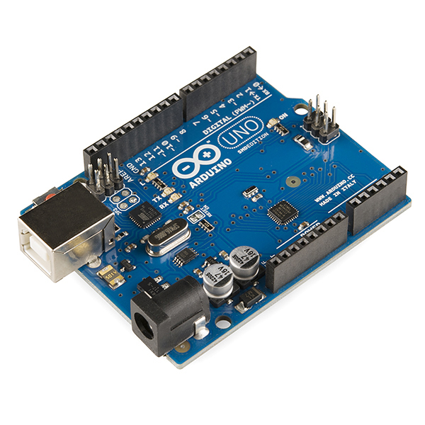

**Fig. 4.2 ARDUINO UNO**

Although it can run on voltages between 7 and 20 volts, it can also be powered by a USB connection or an external 9-volt battery. It is similar to both the Arduino nano and the Leonardo. On the Arduino website, you can download the hardware standard design, which is available under a Creative Commons Attribution Share-Alike 2.5 license. For some hardware variants, layout and production files are also available. The release of Arduino Software 1.0 is denoted by the Italian term "UNO", which means one. Later versions of Arduino were built on top of the UNO hardware and Arduino Software version 1.0. The standard for the platform is the UNO board, the first in a series of USB Arduino boards. The Arduino UNO's ATmega328's pre-programmed boot loader makes it possible to transfer new code to it without the use of an external hardware programmer.

**4.3 GENERAL PIN FUNCTIONS**

* **LED:** Built-in LED powered by digital port 13 is present. The LED is on when the pin has a HIGH value; it is off when the pin has a LOW value.
* **VIN:** The Arduino board's input voltage when using an external power source. This pin can be used to access voltage that has been supplied via the power jack or to give voltage to it.
* **5V:** This pin provides a controlled 5V output from the board's regulator. The board's VIN pin, the USB connector (5V), or the DC power jack (7 to 20V) can all be used to supply electricity to it. (7-20V), by passing the regulator by supplying power through the 5V wires risks damaging the circuit board.
* **3V3:** An internal regulator-generated 3.3-volt source. A 50-mA maximum power draw is allowed.
* **Reset:** Usually applied to shields that obstruct the board's reset mechanism.

**4.4 SPECIAL PIN FUNCTIONS**

Each of the Uno's 14 digital pins and 6 analogue pins can be used as an input or output by using the pin Mode (), digital Write (), and digital Read () functions. They operate on 5 volts. A 20–50k ohm internal pull-up resistor is present on each pin and is by default disconnected. Under recommended working conditions, it can send or receive 20 mA. The highest current draw of any I/O pin must not be exceeded to prevent long-term damage to the microcontroller. Each of the six analogue interfaces on the Uno, with the letters A0 through A5, has a resolution of 10 bits.

**In addition, some pins have specialized functions:**

* **Serial / UART:** pins 0 (RX) and 1 (TX). Used to receive (RX) and transmit (TX) TTL serial data. These pins are connected to the corresponding pins of the ATmega8U2 USB to TTL Serial chip.
* **External Interrupts:** pins 2 and 3. These pins can be configured to trigger an interrupt on a low value, a rising or falling edge, or a change in value.
* **PWM (Pulse Width Modulation):** 3, 5, 6, 9, 10, and 11 Can provide 8-bit PWM output with the analog write () function.
* **SPI (Serial Peripheral Interface):** 10 (SS), 11 (MOSI), 12 (MISO), 13 (SCK). These pins support SPI communication using the SPI library.
* **TWI (Two Wire Interface) / I²C:** A4 or SDA pin and A5 or SCL pin. Support TWI communication using the Wire library.
* **AREF (Analog Reference):** Reference voltage for the analog inputs.

**4.5 LCD DISPLAY**

There are many applications for LCD (Liquid Crystal Display) screens, an electronic display module. A very basic module that is frequently used in many various devices and circuits is a 16x2 LCD monitor. In comparison to multi-segment Light-emitting diodes with seven segments and other segments, these units are preferred as shown in Figure 4.3. A 16x2 LCD has 2 lines, each of which can display 16 letters. On this LCD, each character is displayed using a 5x7 pixel grid. This LCD's two registers are the Command and Data registers. An LCD device receives an instruction when someone tells it to do something, like initialize it, clear its screen, move the cursor, control the display, etc. The data register stores the information that will be displayed on the LCD. The data is the ASCII meaning of the character, which will be displayed on the LCD as shown in Table 4.1.

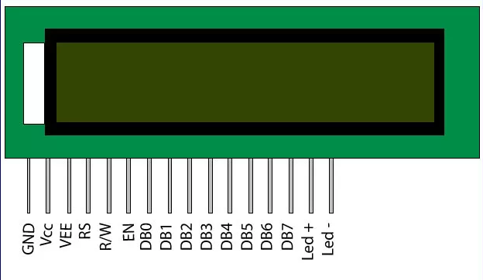

**Fig. 4.3 LCD DISPLAY**

**TABLE.4.1 SPECIFICATION OF LCD DISPLAY**

|  |  |  |
| --- | --- | --- |
| **Pin No** | **Function** | **Name** |
| 1 | Ground (0V) | Ground |
| 2 | Supply voltage; 5V (4.7V – 5.3V) | Vcc |
| 3 | Selects command register when low; and data register when high | Register Select |
| 4 | Low to write to the register; High to read from the register | Read/write |
| 5 | 8-bit data pins | DB0 |
| 6 | DB1 |
| 7 | DB2 |
| 8 | DB3 |
| 9 | DB4 |
| 10 | DB5 |
| 11 | DB6 |
| 12 | DB7 |
| 13 | Backlight VCC (5V) | Led+ |
| 14 | Backlight Ground (0V) | Led- |

**4.6 POWER SUPPLY**

An electrical load is supplied with energy by a device known as a power source. The primary function of a power supply is to transform electric current from a source into the appropriate voltage, current, and frequency to power the application. While some power supplies are separate, stand-alone pieces of machinery, others are integrated into the load appliances they power. Although some power supplies power their loads without wired contacts by using wireless energy transfer, the input and output are typically hardwired circuit connections.

**4.7** **STEPS INVOLVED IN POWER SUPPLY**

**Step 1: Circuit Designing**

1. Decide the regulator to be used and its input voltage.

2. Decide the transformer to be used

3. Decide the value of the filter capacitor

4. Decide the PIV (peak inverse voltage) of the diodes to be used.

**Step 2: Circuit Drawing and Simulation**

A power source is an electrical circuit that converts ac voltage to dc voltage. Most of its parts consist of transformer, rectifier, filter, and regulator circuits. Power supply units are used by computers, amateur radio transmitters and receivers, and every other piece of electrical equipment that takes dc voltage as an input. An uninterruptible power source is required for computers that periodically store volatile data. By doing this, data degradation due to low voltage and power disruptions is prevented. The transformer is a static device that transfers electrical energy from the primary winding to the secondary winding without affecting frequency.

**4.8 FILTER**

The ripple component is kept out of the output with the help of the power supply's filter. Its goal is to convert the pulsing DC levels in rectifier circuits into an appropriate steady DC level. The two main types of power source filters are capacitance filters and RC filters. The C-filter is the easiest and least expensive type of filter. To lessen the voltage fluctuation across capacitor filters, RC- filters are an option. Its primary function is to attenuate the AC component of the transmission while primarily transmitting the DC component.

**4.9 MQ-3 ALCOHOL GAS SENSOR**

A gas detecting element, MQ-3 Liquor is a low-cost semiconductor sensing element that can identify the presence of alcohol vapor gas at amounts between 0.05 and 10 mg/L. It has a high sensitivity to alcohol and a deft resilience to disturbances brought on by smoke vapor and gasoline as shown in Figure 4.4. The sensing element's sensitive material is SnO2, a substance whose conductivity decreases in pure air.

Alcohol vapor gas production will increase, which will improve transmission. The concentration of alcohol sustains the analogue resistive output that the sensing component generates. The motor circuit is extremely straightforward, requiring only a resistance. A simple connection could be a 0-3.3V ADC. The MQ3 alcohol detecting element module has straightforward protocols for working with microcontrollers, Arduino boards, Raspberry Pi, etc.

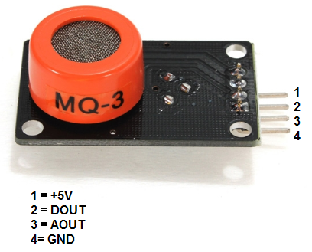

**Fig. 4.4 MQ-3 ALCOHOL SENSOR**

**4.10 MOTOR DRIVE**

Motor drivers are circuits that move motors. Consequently, they are commonly used for motor coupling. The selection of a drive circuit depends on the sort and rating of the motor being used, and they are all easy to interface with the motor.

**4.11 GEARED DC MOTOR**

The DC motor, whose Insight specifics have already been explained here, can be viewed of as an extension of geared DC motors. A geared motor is made by coupling a gear system to a DC motor. The strength of a motor is gauged by its revolutions per minute, or RPM. The creation of the gear head and, consequently, the operation of the geared DC motor will be covered in great depth in this insight.

**CHAPTER 5**

**SYSTEM REQUIREMENTS**

* 1. **HARDWARE REQUIREMENTS**
  + Ignition Switch (ON/OFF)
  + Vibration sensor
  + MQ-3 Alcohol sensor
  + Buzzer
  + Transformer
  + Power Supply Unit
  + Motor
  + Arduino Board
  + LCD display
  + Engine control module

**5.2 SOFTWARE REQUIREMENTS**

**Tools**

* + ARDUINO IDE

**Language**

* + Embedded C

**Mobile** **Application**

* + Blynk IoT (Mobile App)

# CHAPTER 6

**IMPLEMENTATION OF PROPOSED ACCIDENT ANALYSING SYSTEM**

* 1. **WORKFLOW FOR ACCIDENT ANALYSING SYSTEM**

The major goal of this article is to develop a real-time application that utilizes NodeMCU and sensors to detect accidents. We intended to incorporate three modules in this project. When a vehicle is involved in an accident, a Notification alert is immediately sent over NodeMCU to the Configured App as shown in Figure 6.1. Some accidents occurred as a result of drunk driving. So, we can quickly identify if a person has consumed alcohol or not with the use of an alcohol sensor. Once the Alcohol is detected, immediately the speed of the engine will be getting reduced.

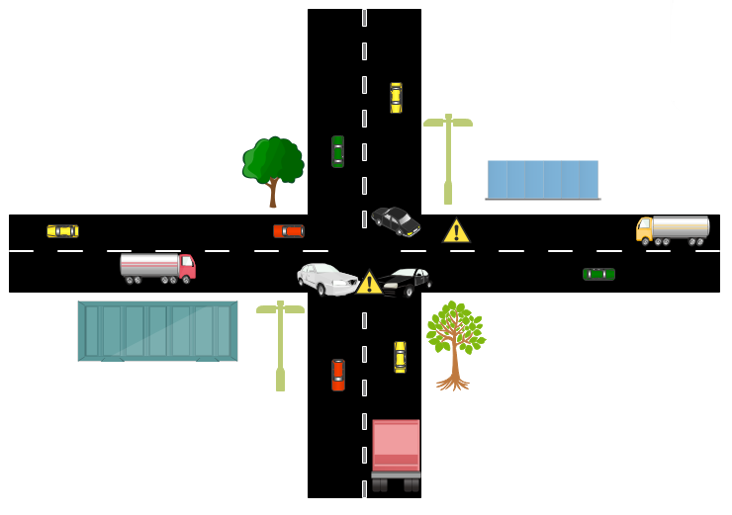

**Fig. 6.1 WORKFLOW OF ACCIDENT ANALYZING SYSTEM**

**6.2 MODULES**

A separate component of hardware or software is known as a module. Modular components typically have two characteristics: portability, which allows them to be used in a range of systems, and interoperability, which allows them to interact with other systems' components.

* Accident Sensing
* Drunk and Drive Detection and Speed Control
* User Models
* Monitoring System
* Performance evaluations

**6.3 ACCIDENT SENSING**

When a car accident happens, the details are shown on the dashboard and a prompt notification is sent to an App. The system will allow the driver 30 seconds to be found; if they are found within that time, they can abort the system and the constant beeping will stop as shown in Figure 6.2. If not, the sound will get louder, which would suggest a potentially hazardous situation for a driver.

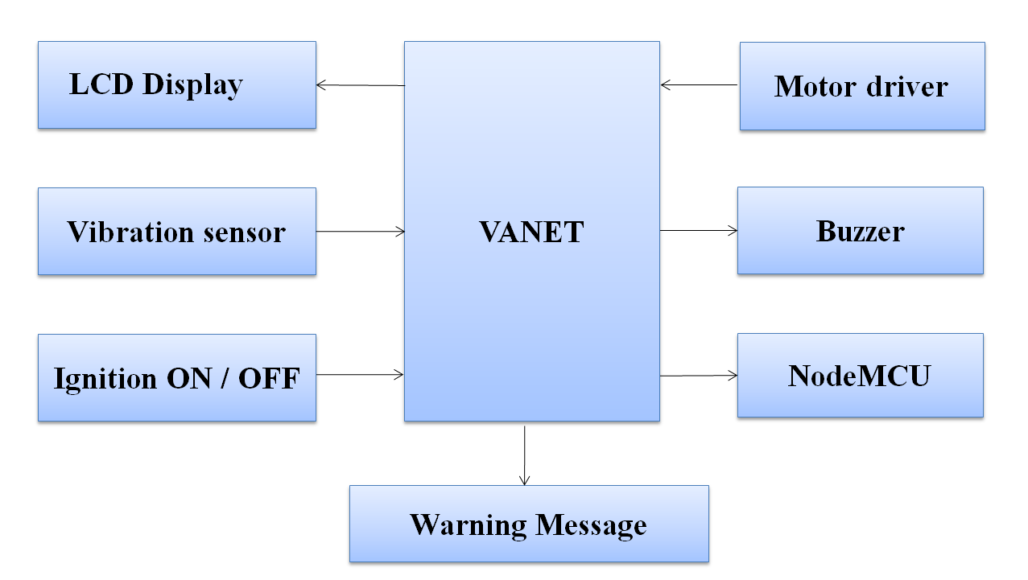

**Fig. 6.2 ACCIDENT SENSING**

**6.4 DRUNK AND DRIVE DETECTION AND SPEED CONTROL**

When a drunk driver operates a vehicle, an alert message is promptly sent to the owner or rescue personnel as shown in Figure 6.3. This module's goal is to determine whether the motorist is intoxicated or not. Because, majorly the car was driven by the drivers. Few people were driving independently means by own. As a result, knowing the driver's state will aid the person who is travelling with the driver.

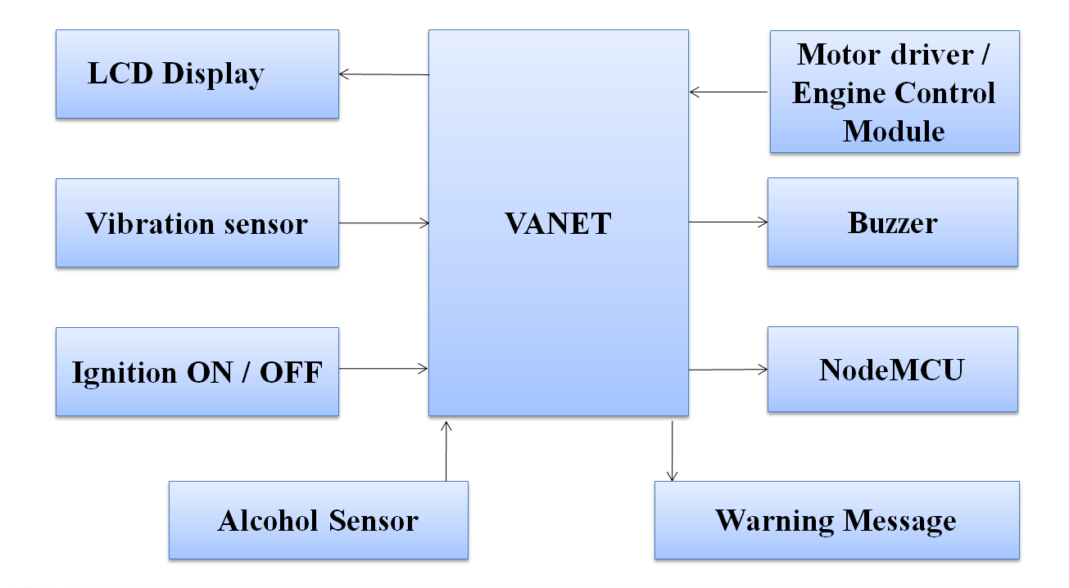

**Fig. 6.3 DRUNK AND DRIVE DETECTION AND SPEED CONTROL**

**6.5 USER MODULES**

New users can register by entering their accurate information on the user registration page, which includes an email address, user name, phone number, etc. A message cannot be displayed until all sections have been filled out by the user. The information is sent to the database when the user clicks the register button after filling out all the forms. Here, it checks to see if the email address is already in the user table; if it is, an error notice is shown; if not, the data is saved in the user database. Users check the home website to see if all the information is correct.

**6.6 DRIVER LEVEL MANAGEMENT**

The “Alcohol Detection with Vehicle Controlling” feature of this system is mainly used to prevent accidents brought on by drunk driving. The alcohol monitor is connected to the PCB. When the blood alcohol level is higher than the allowed maximum, the car's ignition is turned off. This system needs to be installed in the car.

**6.7 MONITORING SYSTEM**

The sensors in this system are directly facing the driver's face. This system monitors the driver's eyes and uses LED and LDR technology to detect the pulse from their fingers to determine whether they are conscious or asleep. Analyze the sensor data to ascertain the level of fatigue.

**6.8 PERFORMANCE EVALUATIONS**

It's not a new concept to use IoT to identify DUI. There are numerous instances in written works. However, no one tactic has been employed frequently. Complexity, scalability, and implementation trouble are problems that the various approaches raise. Therefore, in new versions, accuracy, simplicity, and affordability must be preserved. IoT usage creates unique challenges in this field. Although readily available, alcohol content detection sensors are not well integrated inside of cars. Once the alcohol sensor detects alcohol levels above a predetermined range, the alarm is triggered, alerting both the driver's family and the local traffic control. When the alcohol content exceeds 200 mg/L, the engine is switched off. The basic system is built around the simple alcohol monitor.

**CHAPTER 7**

**HARDWARE & SOFTWARE REQUIREMENTS**

**7.1 ARDUINO IDE**

Although the Arduino IDE is extremely simple, it offers a nearly perfect environment for the majority of Arduino-based projects. Standard menu items such as "File" (new, load, save, etc.), "Edit" (font, copy, paste, etc.), "Sketch" (for compiling and programming), "Tools" (useful choices for testing projects), and "Help" are available in the upper menu bar. The simple text interface in the middle of the IDE is where you enter program code. The output pane, which can be found at the base of the IDE, is where you can see details like memory utilization, compilation status, program errors, and other useful messages.

**7.2 EMBEDDED C**

In order to address issues with compatibility between C extensions for different systems, the C Standards Committee created Embedded C as a collection of language extensions for the C programming language. Named address spaces, fixed-point math, and basic I/O hardware addressing are just a few of the elements that are absent from standard C. An add-on for the C programming language called Embedded C facilitates the development of successful apps for embedded hardware. It does not belong to C. Embedded C is one of the most popular and commonly used programming languages when developing embedded systems.

**CHAPTER 8**

# TESTING

**8.1 SYSTEM TESTING**

System testing is the process of testing a completed, fully integrated software product. Typically, software is just a small part of a larger computer-based system. Software ultimately establishes connections with hardware and other software. System testing is actually a collection of different tests carried out exclusively to put the complete computer-based system to the test.

**8.2 UNIT TESTING**

Unit testing is a type of software testing where individual software components are assessed. Verifying that each piece of software performs as designed is the aim. A unit is the lowest testable portion of any program. An object-oriented method, which can be found in a super class, abstract class, or child class, is the simplest building block in an object-oriented program. The use of frameworks, drivers, prototypes, and fictitious items helps unit testing.

**8.3 INTEGRATION TESTING**

Integration testing is the stage of software development where different software components are combined and tested as a whole. This level of testing aims to find problems with the interactions between integrated components. Test drivers and test proxies are helpful for integration testing. In the integration testing phase of software testing, different software modules are combined and assessed simultaneously. Integration testing is performed to see if a system or component satisfies a set of practical requirements.

# CHAPTER 9

# EXPERIMENTAL RESULTS AND DISCUSSION

# 9.1 RESULTS OF VEHICLE ACCIDENT SENSING

# The sensing phase includes accident identification, detection and tracking with using of deep network layer and intimation of vehicle accident incidences to the close by rescue center. The function of the system will be clearly as shown in Figure 9.1. The SW420 vibration sensor is used to establish collision detection. When an aberrant jerk or vibration is detected that exceeds the predetermined threshold, the sensor output spikes, activating the buzzer. We have set the threshold value at 80000 for prototype demonstration reasons. The rescue squad will then receive the alarm message instantly.

# 

# Fig. 9.1 FLOW OF ACCIDENT SENSING

# 9.2 RESULTS OF VEHICLE ALCOHOL DETECTION

# Internal initialization has set the MQ3 sensor's threshold to 500 ppm. The NodeMCU will be activated through server whenever the alcohol concentration exceeds the threshold. The chosen mobile number will then receive the alert message through NodeMCU. The Alcohol detection of the system will be shown in Figure 9.2. The identical thing has been shown with an L293D motor driver. An alcohol-based hand sanitizer has been employed for testing purposes; when it is detected, a notice is delivered.

# 

# Fig. 9.2 ALCOHOL DETECTION FLOW

# 9.3 RESULTS OF SPEED ALERT DETECTION

# The server will trigger the Engine Control Module and Vehicle Speed Sensor when the automobile exceeds the speed limit 80km/h. The limit of the vehicle fixed is shown in Figure 9.3. The NodeMCU Module will then activate the two sensors. The rescue squad will immediately receive an alert message if the NodeMCU Module detects vibration.

# 

# Fig. 9.3 SPEED ALERT

# 9.4 RESULTS OF ACCIDENT RECOGNITION USING CNN

# It is suggested that a deep learning Convolutional neural network be applied to each frame of a motion picture that has been trained to distinguish between accident and non-accident-related video frames. It has been determined that Convolutional Neural Networks provide a quick and reliable method for classifying images. For comparatively smaller datasets, CNN-based image classifiers have achieved accuracy levels of above 95% and need less preprocessing than other image classifying techniques.

# 9.5 DISCUSSION

# A vehicle ad hoc network technique is made up of several moving or stationary cars that are connected by a wireless network. VANETs were primarily used until recently to improve driver comfort and safety in moving cars. Through the VANET, the vehicles in the road were connected in a wireless medium. This will help us to transmit the alert signal through waves. The VANET will be connected with the Server. Once the motor starts VANET will be activated through Server. Tensor Flow is a full open resource Artificial Intelligence platform.

# Tensor Flow provides a vast, comprehensive network of methods, databases, and group of people properties that let researchers shove the limitations of machine learning and implementers will quickly and effectively create and organize machine learning origins. The actuators in a combustion engine are managed by an ECU, also indicated to an ECM, to ensure optimum engine performance. Then, the conventional speedometer is replaced by a speed sensor. It rotates while being plugged into an electrical connector that can send a signal to a computer. In this manner, the sensor offers data for calculating your car's speed. It also displays whether you need to change the transmission speed or shift levels.

# 

**CHAPTER 10**

**CONCLUSION & FUTURE WORK**

In comparison to the current systems, the proposed approach is significantly more dependable and may be more efficient. In proposed system we are able to detect accident normally also the accident happened because of consuming alcohol. When the Alcohol is detected the engine speed will be reduced automatically. The key benefit of this research is that, it allows us to prevent the over speed during intoxicated. In the future, we planned to implement in a real time basis, also with the help of GSM and GPRS we sent an alert message and current locations to the rescue team or relatives.

**CHAPTER 11**

**APPENDICES**

**11.1 SAMPLE CODE**

**accident.h**

#include <SoftwareSerial.h>

/* LCD RS pin to digital pin 8

* LCD Enable pin to digital pin 9

* LCD D4 pin to digital pin 10

* LCD D5 pin to digital pin 11

* LCD D6 pin to digital pin 12

* LCD D7 pin to digital pin 13

* LCD R/W pin to ground

* LCD VSS pin to ground

* LCD VCC pin to 5V*/

#include <LiquidCrystal.h>

const int rs = 13, en = 12, d4 = 11, d5 = 10, d6 = 9, d7 = 8;

int m11=2; // rear motor

int m12=3;

int m21=4; // front motor

int m22=5;

int sen=0;

void backward()

{

digitalWrite(m11, HIGH);

digitalWrite(m12, LOW);

digitalWrite(A3,HIGH);

digitalWrite(A4,LOW);

}

void forward()

{

digitalWrite(m11, LOW);

digitalWrite(m12, HIGH);

digitalWrite(A3,LOW);

digitalWrite(A4,HIGH);

}

void Stop()

{

digitalWrite(m11, LOW);

digitalWrite(m12, LOW);

digitalWrite(A3,LOW);

digitalWrite(A4,LOW);

}

SoftwareSerial gsm(6,7);

LiquidCrystal lcd(rs, en, d4, d5, d6, d7);

void setup()

{

lcd.begin(16, 2);

lcd.setCursor(0,0);

lcd.print("SMART ACCIDENT");

lcd.setCursor(0,1);

lcd.print("DETECTION");

delay(3000);

gsm.begin(9600);

Serial.begin(9600);

pinMode(m11, OUTPUT);

pinMode(m12, OUTPUT);

pinMode(m21, OUTPUT);

pinMode(m22, OUTPUT);

delay(5000);

deviceInitialise();

}

void serialdata()

{

while(gsm.available())

{

Serial.print(gsm.read());

}

}

void loop() {

sen=analogRead(A0);

Serial.println(sen);

delay(1000);

if(sen<=900)

{

Stop();

lcd.clear();

lcd.setCursor(0,0);

lcd.print(“ACCIDENT”);

lcd.setCursor(0,1);

lcd.print(“DETECTED”);

delay(1000);

gsm.println("AT+HTTPPARA=\"URL\",\"http://www.isquaresoftware.com/hcc/acupdate.php?flag=1\"");

delay(5000);

serialData();

gsm.println("AT+HTTPPARA=\"CID\",1");

delay(5000);

serialData();

gsm.println("AT+HTTPACTION=0");

delay(1000);

delay(10000);

}

// Serial.println(analogRead(A2));

if(analogRead(A5)<=750)

{

forward();

delay(1000);

}

//Serial.println(analogRead(A5));

if(analogRead(A2)<=750)

{

backward();

delay(1000);

}

Stop();

}

void deviceInitialise()

{

lcd.clear();

lcd.setCursor(0,0);

lcd.print("INITIALISING....");

delay(5000);

gsm.println("AT");

delay(10000);

serialData();

gsm.println("AT+CGATT=1");

delay(5000);

serialData();

gsm.println("AT+SAPBR=3,1,\"Contype\",\"GPRS\"");

delay(5000);

serialData();

gsm.println("AT+SAPBR=3,1,\"APN\",\"internet\"");

delay(5000);

serialData();

gsm.println("AT+SAPBR=1,1");

delay(5000);

serialData();

gsm.println("AT+SAPBR=2,1");

delay(5000);

serialData();

gsm.println("AT+HTTPINIT");

delay(5000);

serialData();

lcd.setCursor(0,1);

lcd.print(" READY TO USE ");

}

void serialData()

{

while(gsm.available()!=0)

Serial.write(gsm.read());

}

**alcohol.h**

#include <SoftwareSerial.h>

/* LCD RS pin to digital pin 8

* LCD Enable pin to digital pin 9

* LCD D4 pin to digital pin 10

* LCD D5 pin to digital pin 11

* LCD D6 pin to digital pin 12

* LCD D7 pin to digital pin 13

* LCD R/W pin to ground

* LCD VSS pin to ground

* LCD VCC pin to 5V*/

#include <LiquidCrystal.h>

const int rs = 13, en = 12, d4 = 11, d5 = 10, d6 = 9, d7 = 8;

int m11=2; // rear motor

int m12=3;

int m21=4; // front motor

int m22=5;

int sen=0;

void backward()

{

digitalWrite(m11, HIGH);

digitalWrite(m12, LOW);

digitalWrite(A3,HIGH);

digitalWrite(A4,LOW);

}

void forward()

{

digitalWrite(m11, LOW);

digitalWrite(m12, HIGH);

digitalWrite(A3,LOW);

digitalWrite(A4,HIGH);

}

void Stop()

{

digitalWrite(m11, LOW);

digitalWrite(m12, LOW);

digitalWrite(A3,LOW);

digitalWrite(A4,LOW);

}

SoftwareSerial gsm(6,7);

LiquidCrystal lcd(rs, en, d4, d5, d6, d7);

void setup()

{

lcd.begin(16, 2);

lcd.setCursor(0,0);

lcd.print("SMART ALCOHOL");

lcd.setCursor(0,1);

lcd.print("DETECTION");

delay(3000);

gsm.begin(9600);

Serial.begin(9600);

pinMode(m11, OUTPUT);

pinMode(m12, OUTPUT);

pinMode(m21, OUTPUT);

pinMode(m22, OUTPUT);

delay(5000);

deviceInitialise();

}

void serialdata()

{

while(gsm.available())

{

Serial.print(gsm.read());

}

}

void loop()

{

sen=analogRead(A0);

Serial.println(sen);

delay(1000);

if(sen>=400)

{

Stop();

lcd.clear();

lcd.setCursor(0,0);

lcd.print("DRIVER CONSUMING");

lcd.setCursor(0,1);

lcd.print("ALCOHOL");

delay(1000);

gsm.println("AT+HTTPPARA=\"URL\",\"http://www.isquaresoftware.com/hcc/alupdate.php?flag=1\"");

delay(5000);

serialData();

gsm.println("AT+HTTPPARA=\"CID\",1");

delay(5000);

serialData();

gsm.println("AT+HTTPACTION=0");

delay(1000);

delay(10000);

}

// Serial.println(analogRead(A2));

if(analogRead(A5)<=750)

{

forward();

delay(1000);

}

//Serial.println(analogRead(A5));

if(analogRead(A2)<=750)

{

backward();

delay(1000);

}

Stop();

}

void deviceInitialise()

{

lcd.clear();

lcd.setCursor(0,0);

lcd.print("INITIALISING....");

delay(5000);

gsm.println("AT");

delay(10000);

serialData();

gsm.println("AT+CGATT=1");

delay(5000);

serialData();

gsm.println("AT+SAPBR=3,1,\"Contype\",\"GPRS\"");

delay(5000);

serialData();

gsm.println("AT+SAPBR=3,1,\"APN\",\"internet\"");

delay(5000);

serialData();

gsm.println("AT+SAPBR=1,1");

delay(5000);

serialData();

gsm.println("AT+SAPBR=2,1");

delay(5000);

serialData();

gsm.println("AT+HTTPINIT");

delay(5000);

serialData();

lcd.setCursor(0,1);

lcd.print(" READY TO USE ");

}

void serialData()

{

while(gsm.available()!=0)

Serial.write(gsm.read());

}

**11.2 SCREENSHOTS**

|  |  |
| --- | --- |
|  |  |
| **Fig. 11.1 IGNITION OFF STATE** | |
|  |  |
| **Fig. 11.2 IGNITION ON STATE** | |

|  |  |
| --- | --- |
|  |  |
| **Fig.11.3 ACCIDENT DETECTED STATE** | |
|  |  |
| **Fig.11.4 ALCOHOL DETECTED STATE** | |

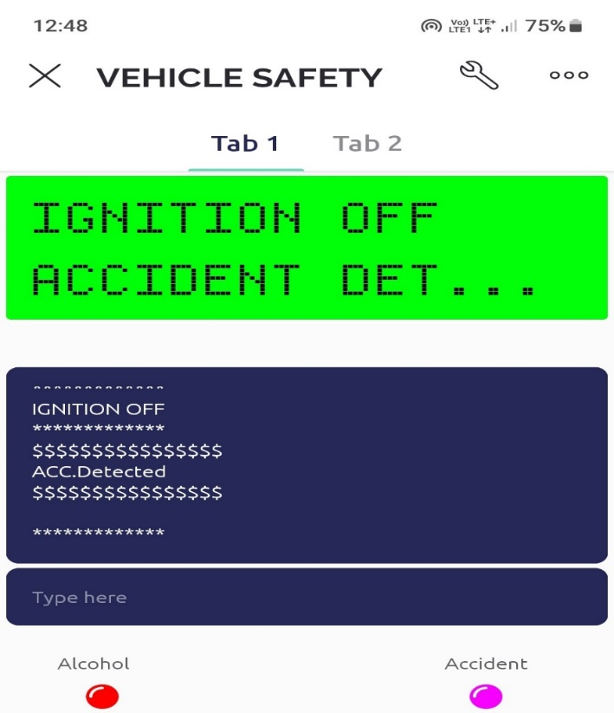

# 

# Fig. 11.5 ALCOHOL AND ACCIDENT DETECTED STATE

# REFERENCES

# [1] Da-Jie Lin, Mu-Yen Chen and Hsiu-Sen Chiang (2021) ‘Intelligent Traffic Accident Prediction Model for Internet of Vehicles with Deep Learning Approach’ IEEE Transactions on Intelligent Transportation Systems, vol. 42, pp. 7-8.

# [2] Ehsan Khosravi, Ali Mohammad and Afshin Hematyar (2022) ‘Safe Deep Driving Behavior Detection (S3D)’ IEEE SYSTEMS, Man and Cybernetics Society Section, vol. 33, pp. 1-9.

# [3] Levent Guvenc (2020) ‘Preventive and Active Safety Applications’ IEEE Publications, vol. 5, pp. 34437.

# [4] Le Yu, Bowen Du, Xiao Hu, Leilei Sun, Liangzhe Han and Weifang Lev (2020) ‘Deep spatio-temporal graph convolutional network for traffic accident prediction’ Elsevier Article, pp. 1582.

# [5] Nikhil Kumar, Debopam Acharya, and Divya Lohani (2020) ‘An IoT Based Vehicle Accident Detection and Classification System using Sensor Fusion” IEEE Transactions on Intelligent Transportation Systems, vol. 88, pp. 9-10.

# [6] Nikhlesh Pathik, Rajeev Kumar Gupta, Yatendra Sahu (2022) ‘AI Enabled Accident Detection and Alert System Using IoT and Deep Learning for Smart Cities’ IEEE Journal on selected areas in communications, vol. 14, pp. 7701.

# [7] Rui Huang, Hui Liu, Hongliang Ma (2022) ‘Accident Prevention Analysis: Exploring the Intellectual Structure of a Research Field’ MDPI Publisher, vol. 14, pp. 8784.

# [8] Sai Huang, Yuanyuan Yao, Zhengyu Zhu (2020) ‘Energy Efficiency Characterization in Heterogeneous IoT System with UAV Swarms Based on Wireless Power Transfer’ IEEE Transactions on Industriel Informatics, vol. 8, pp. 1417-1425.

# [9] Sumit Mishra, Praveen Kumar Rajendran, Luiz Felipe Vecchietti (2022) ‘Sensing accident-prone features in urban scenes for proactive driving and accident prevention’ IEEE Publications, vol. 18, pp. 4410.

# [10] Unaiza Alvi1, Muazzam A. Khan Khattak (2020) ‘A Comprehensive Study on IoT Based Accident Detection Systems for Smart Vehicles’ IEEE Journal on selected areas in communications, vol. 8, no. 4.

**LIST OF PUBLICATIONS**

M.R.S.Abirame, A.Madhupriya, R.Nikalya, M.Prithiusha, ‘A Novel Approach for Vehicular Accident Detection and Rescue Alert System using IOT with Convolutional Neural Network’ , International Conference on Advanced Computing & Communication Systems (ICACCS - 2023), IEEE Explore at Sri Eshwar College of Engineering, Coimbatore, 17 – 18 March 2023.



 

 

 